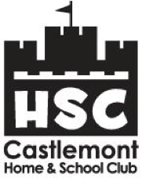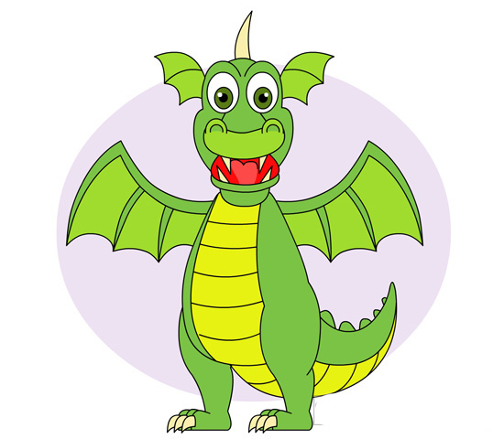

* I do not want to cut box tops. Here’s $10 instead!
* I love Castlemont, but don’t need any wrapping paper. Here’s $50 instead.
* We enjoy popcorn and cookie dough, but don’t need any more in our house. Here’s another $50.
* I don’t want to hit up family and friends to sponsor my child for the jog-a-thon. Here’s $50 more.
* We don’t want to stand in line for popcorn, frozen yogurt, or shave ice. Here’s $40.
* I am making a general donation in appreciation of not having to buy, sell, or do anything except   
  fill out this form!

Donations of $250 or higher will be entered to win 1 of 5 Family Fall Festival bracelets and 1 of 3 yearbooks. Please cut and return the bottom portion to your child’s teacher or the front office with your $250 donation to be entered to win



**Parent Name:________________________________________________________________________________**

**Childs Name(s):___________________________________________________ Grade:_____________________**

**Teacher:____________________________________________________________________________________**

**Email (provide for a donation letter)_____________________________________________________________**

**Don’t forget to ask your employer about company matching. Castlemont HSC nonprofit ID# is 77-0083177.**

Castlemont Home & School Club

## Giving Drive

With your help, Castlemont HSC can reach our goal of raising $100,000 for our school. Every dollar counts! **100% of your donation will directly benefit Castlemont Students and teachers!**